# Bahria University,

## Karachi Campus



COURSE: SEL-448

SOFTWARE APPLICATION FOR MOBILE DEVICES

TERM: SPRING 2024, CLASS: BSE- 6(B)

Submitted By:

Muhammad Shoaib Akhter Qadri_____________79290___

(Name) (Reg. No.)

Submitted To:

Engr. Hamza / Engr. Adnan u Rahman

Signed Remarks: Score:__

INDEX

|  |  |  |  |  |
| --- | --- | --- | --- | --- |
| SNO | DATE | LAB NO | LAB OBJECTIVE | SIGN |
| 01 | 16/02 | 01 | Introduction to Android Studio |  |
|  |  |  |  |  |
|  |  |  |  |  |
|  |  |  |  |  |
|  |  |  |  |  |
|  |  |  |  |  |
|  |  |  |  |  |
|  |  |  |  |  |
|  |  |  |  |  |
|  |  |  |  |  |
|  |  |  |  |  |
|  |  |  |  |  |

# Bahria University,

## Karachi Campus



LAB EXPERIMENT NO.

**_01_**

LIST OF TASKS

|  |  |
| --- | --- |
| **TASK NO** | **OBJECTIVE** |
| 01 | Setup Android Studio on your system |
| 02 | Create a birthday Card Android App using Android Studio in Java language. |
|  |  |
|  |  |
|  |  |
|  |  |
|  |  |
|  |  |
|  |  |
|  |  |
|  |  |

Submitted On:

Date: 15/02/2024

**Task No 01:** Setup Android Studio on your system

**Solution:**

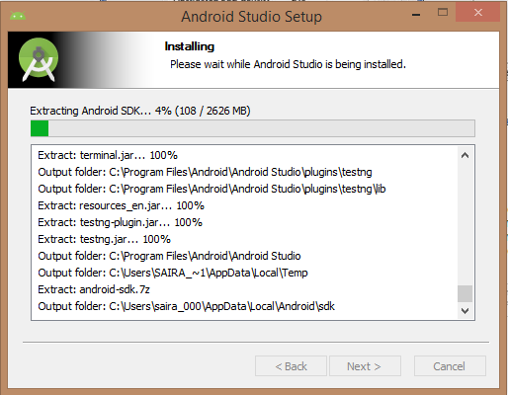

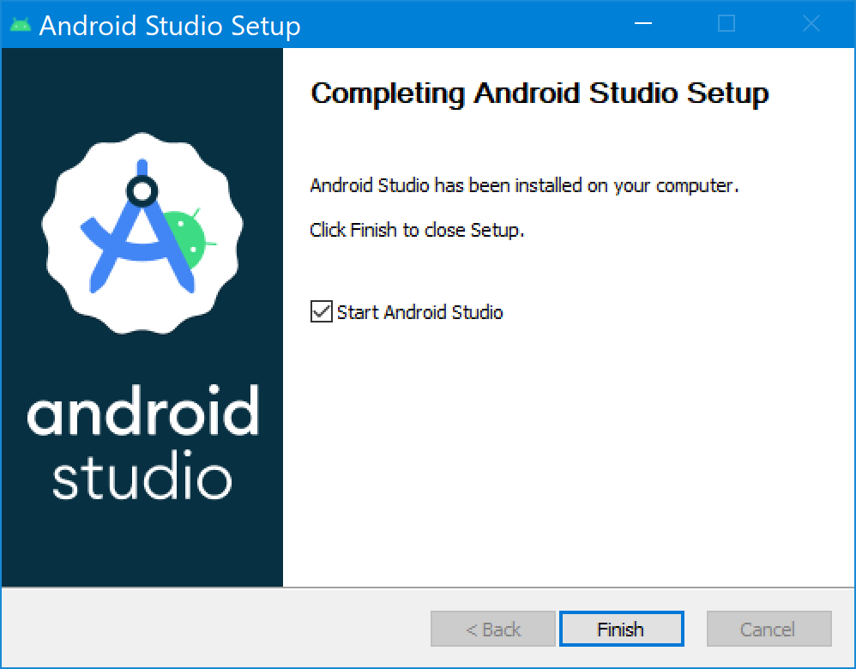

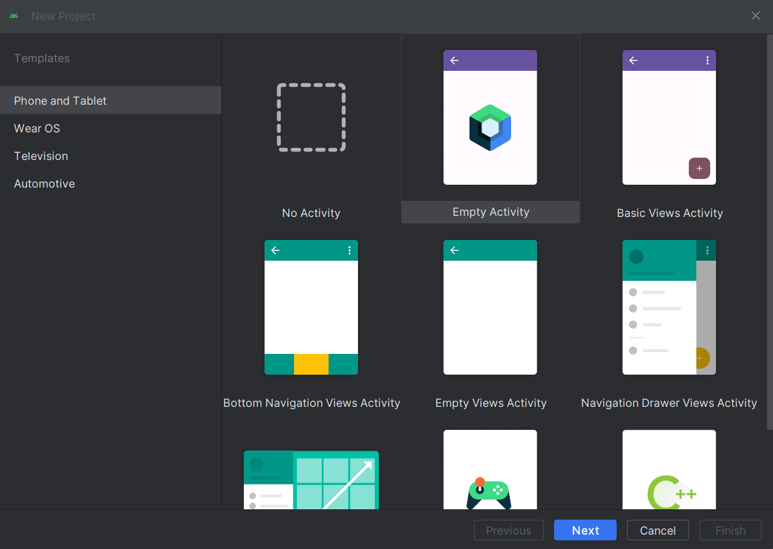

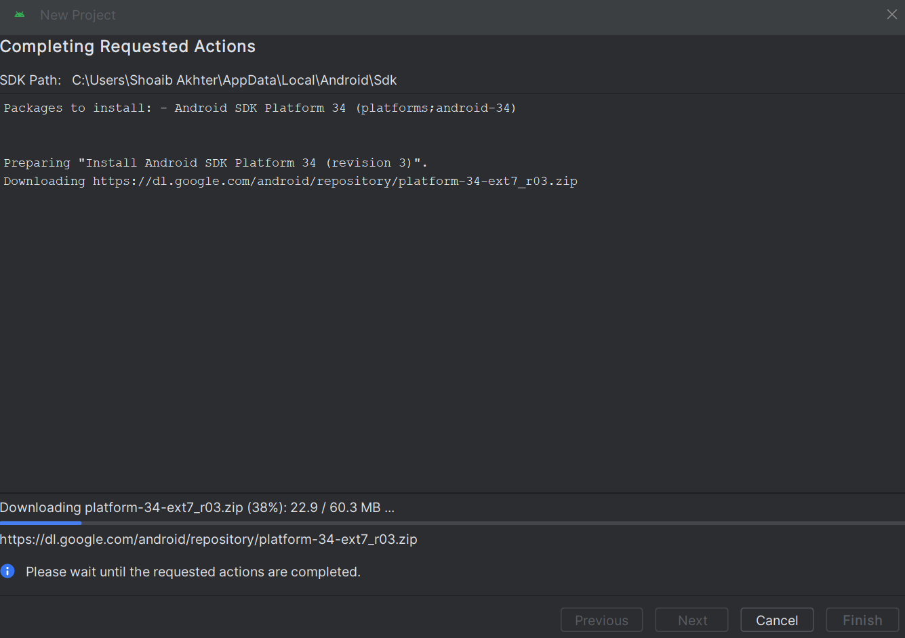

**Task No 02:** Create a birthday Card Android App using Android Studio in Java language.

**Solution:**

MainActivity.java:

package com.example.myapplication;  
  
import androidx.appcompat.app.AppCompatActivity;  
  
import android.os.Bundle;  
import android.widget.ImageView;  
  
public class MainActivity extends AppCompatActivity {  
  
 @Override  
 protected void onCreate(Bundle savedInstanceState) {  
 super.onCreate(savedInstanceState);  
 setContentView(R.layout.*activity_main*);  
  
 }  
}

activity_main.xml:

<?xml version="1.0" encoding="utf-8"?>  
<androidx.constraintlayout.widget.ConstraintLayout xmlns:android="http://schemas.android.com/apk/res/android"  
 xmlns:app="http://schemas.android.com/apk/res-auto"  
 xmlns:tools="http://schemas.android.com/tools"  
 android:layout_width="match_parent"  
 android:layout_height="match_parent"  
 tools:context=".MainActivity">  
  
 <TextView  
 android:layout_width="wrap_content"  
 android:layout_height="wrap_content"  
 android:text="Happy Birthday Shoaib Akhter!"  
 app:layout_constraintBottom_toBottomOf="parent"  
 app:layout_constraintEnd_toEndOf="parent"  
 app:layout_constraintStart_toStartOf="parent"  
 app:layout_constraintTop_toTopOf="parent"  
 app:layout_constraintVertical_bias="0.345" />  
  
 <ImageView  
 android:layout_width="match_parent"  
 android:layout_height="wrap_content"  
 android:src="@drawable/my_image"  
 tools:layout_editor_absoluteX="-94dp"  
 tools:layout_editor_absoluteY="330dp"   />  
  
  
</androidx.constraintlayout.widget.ConstraintLayout>

**Output:**

